The Awakening of Thorus Design Document

Team 4

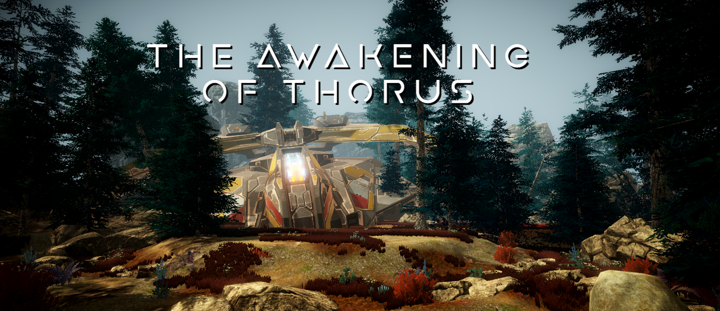

Design Lead: Pietro – Production Lead: Jake – Art & Audio Lead: Nina – QA Lead: Nick – Technical Lead: Jon
Contents
Overview 4
X Statement 4
High Level Concept 4
Pillars 4
Audience 4
Target Audience 4
Persona/s 4
Target Platform 5
Creative Direction 5
Story & Theme 5
Gameplay 5
Final Project Scope 5
Gameplay & Systems 6
Gameplay Overview 6
Core Mechanics 7
Main Game Loop 10
Game Structure 11
Controls 18
Narrative Design 19
Art/Audio Direction 20
Art 20
Art Style Production considerations 22
Audio 22
Audio Style Production considerations 22
Asset List 23
Technical Considerations 26
Target Platform 26
Gameplay & Systems 26
Art & Audio 27
Project Structure & Naming Conventions 28
Production Schedule 29
Overall Test Strategy 36
Feature Test Plan 36
Bug Report Workflow 39
Meeting Notes 40

Overview

X Statement
Anthem meets Dishonoured – the aesthetics from Anthem and the abilities from Dishonoured.

High Level Concept
The game is a fast-paced sci-fi shooter, based in an alien world, that has a light-hearted but deep narrative with a hidden story within it. It is playable on personal computers with Windows operating systems. The game is a true celebration of the fantasy sci-fi stories that touched many generations of various media genres. It is a combination between exciting combat and interesting narrative elements through whose interplay players can experience satisfying and immersive gameplay experience.

Pillars
Fluidity – everything from mechanics and narrative to aesthetics and atmosphere feels enjoyable to experience.
Quality – the highest quality of end-product creates memorable experiences and satisfying consumer needs.
Depth – the amount of detail and richness of the story fulfils players’ curiosity and creates immersive play.

Audience

Target Audience
The target audience is everyone from teen up since the content itself is will contain minor violence, some suggestive themes, crude humour and sometimes strong language. This audience is chosen because first-person shooters are extremely popular within these types of players, as it can be seen from success and demand for games like Fortnite, Apex Legends, Call of Duty and Battlefield.

Persona/s
Our targeted players are gamers who prefer FPSs above any other genre and like single player as well as multiplayer mode. They prefer playing on personal computers rather than consoles. In their free time, they would rather spend their time indoors than outdoors. If they do not make their own money, their parents prefer buying games which do not overwhelmingly consume too much continuous time. They also need to balance their time between work/school obligations and spare time.
The design reflects our audience in a way that allows spontaneous gameplay. Game sessions can be stopped at any time as there will be multiple checkpoints in the game, which means players will be able to easily move their concentration from the game to their other responsibilities. Even though there will be only single-player mode, our audience will still experience the gratifying experience of the first-person shooter.

Target Platform
The target platform for the game is the PC, Windows 10 specifically. This is as a starting point to see if the reception is good and is the quickest to test due to it being the same as the development platform. If it is well received, branching out to other operating systems could be beneficial. This also could include a Virtual Reality version that makes full use of the teleportation mechanics. However, there would need to be lots of modifications in the rest of the game to get it to work on the VR platform.

Creative Direction

Story & Theme
At the core of the game story is a character named Erro, a Terrain who lives by his own rules in a fantasy sci-fi universe. His main occupation is to respond to contracts which seem most profitable to him, and they vary from collecting materials from different planets to delivering objects from one edge of the galaxy to the other. His best friend is a humanized AI called E.T.H.A.N. which stands for “extremely talented human artificial network”. They work together very well, and their relationship is a narrative tool to express an opinion that people need to have someone to lean on, as everything is easier with a little support, not matter in what form that support is. Their journey is set on unexplored planet called Thorus, where they need to collect certain materials for their business contract. Their focus swifts when they discover a lead which turns their assignment into a search for a mysterious ancient artifact.
The story is told through Erro’s and E.T.H.A.N.’s dialogue which consists of many comic elements to create an atmospheric environment similar to the one in the Guardians of the Galaxy. Additionally, the overall art style and level design will work together to create a feeling of an alien and uncharted planet in which players feel like intruders, as we are trying to deliver an interesting and mysterious player experience.

Gameplay
This game should feel smooth and fun to play. The mix of high paced action and slower story elements should keep the player interested throughout the entire game experience. The combination of the dash and teleport abilities should allow the player to have close calls and dance around the enemies, but it isn’t that easy. The enemies are clever, dodging out the way of bullets and teleporting around the battlefield. These enemies should be manageable on their own, but in swarms can tear apart the player. Stealth isn’t an option in the game, but taking on enemies one at a time, carefully, is. The idea is to keep the player moving in the combat areas otherwise the game would feel slow. The most recent Doom game represents exactly what we are going for in the fluidity of movement.

Final Project Scope
The game proposed here, is the entire game. The initial showcase is the ‘vertical slice’ for the game. Most of the gameplay features will be in the Art Showcase, which shows how the beginning of the game starts. The one of the reasons for making the ‘vertical slice’ the start of the game, allows the game to be developed to the best quality from start to finish with the ability to change the finish point dependent on development progress. Each section is being brought into fruition through the level design. Once that section of the level is planned out and represented in virtual space, all focus goes onto that section of the game to fill it with the content of the game.

Gameplay & Systems

Gameplay Overview
The main gameplay actions that will be performed by the player will be exploring and fighting. The former refers to the player’s capability of finding objects to interact with and understanding the narrative through them. The latter refers to the player’s abilities that will allow him to defeat enemies and progress in the game.
Finally, the game identifies itself as a sci-fi themed first-person shooter and role-playing game.

Core Mechanics
Dashing: The player can quickly cover a short distance by pressing one of the walking keys plus using the left ctrl key. The dashing force will be set to twenty-five and the cooldown to one second.
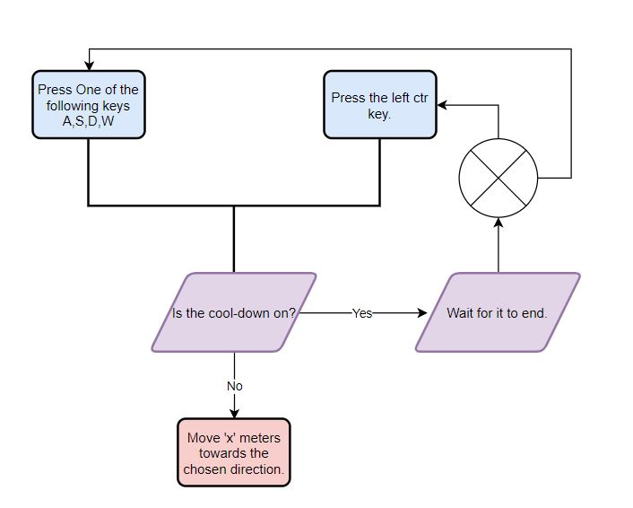
Figure 1: Dash Mechanic

Teleporting: The player can instantly travel through space by holding the E Key (A teleport marker will appear showing the player its next location) and then releasing it (The player will be instantly teleported to the teleport marker location). The maximum distance that the player can cover will be set to twenty and the cooldown to one second.
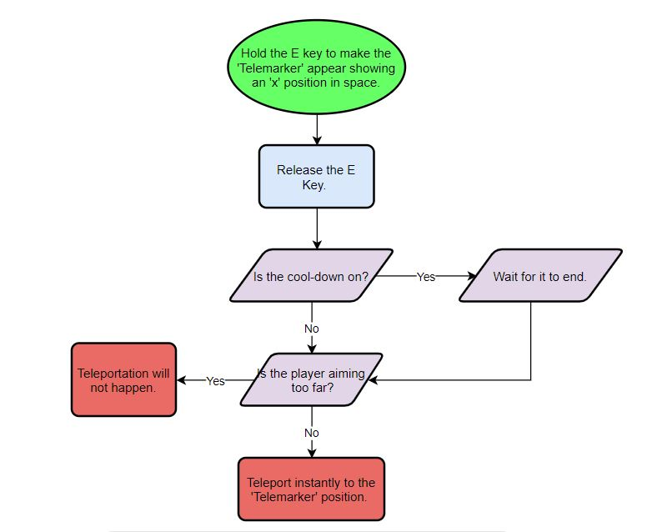
Figure 2: Teleporting Mechanic
Shooting: The player can shoot projectiles that travel through space and deal damage to enemies. The speed will be set to thirty-five and the capacity of the magazine will be set to six.
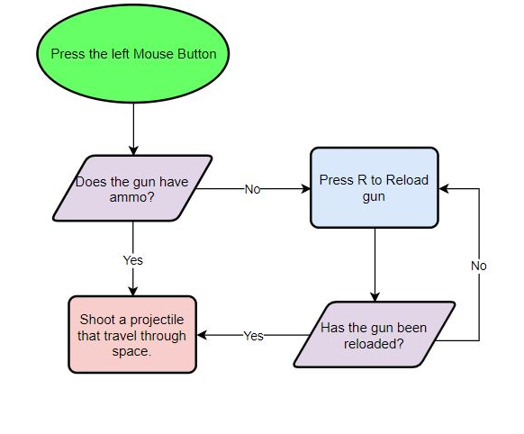
Figure 3: Shooting Mechanic

Main Game Loop
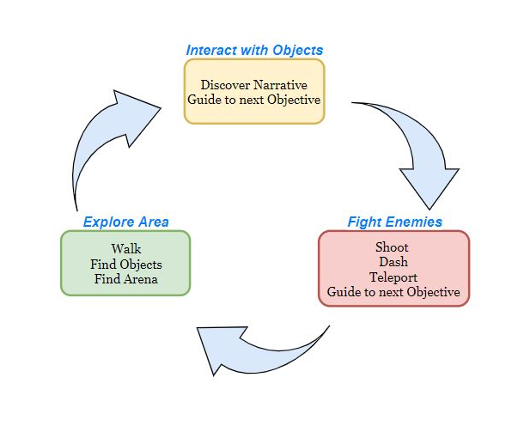
Figure 4: Main Game Loop

Game Structure

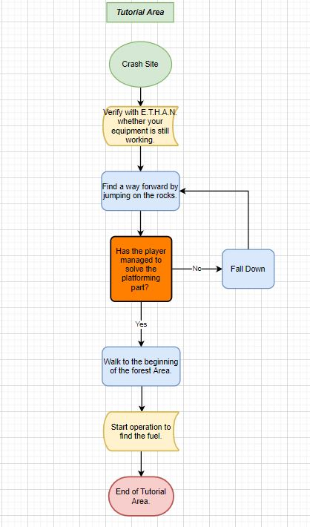
Figure 5: Tutorial Area
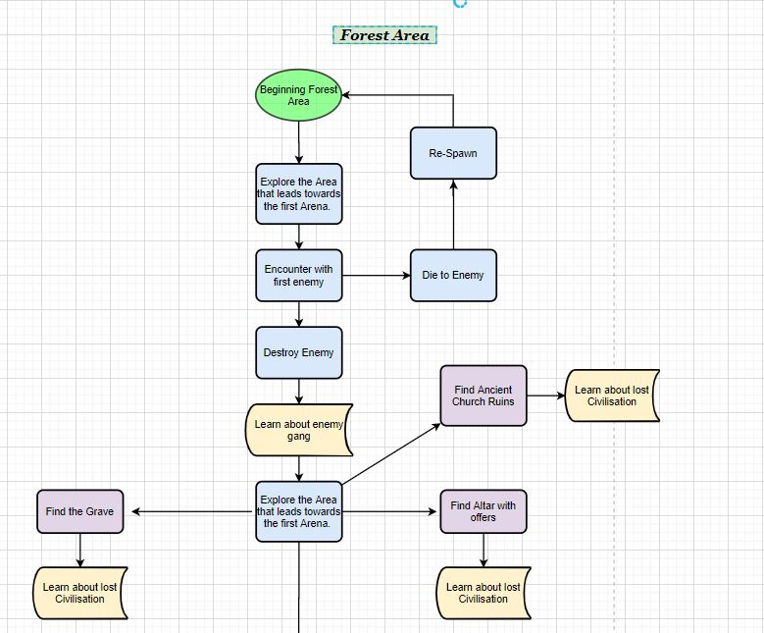

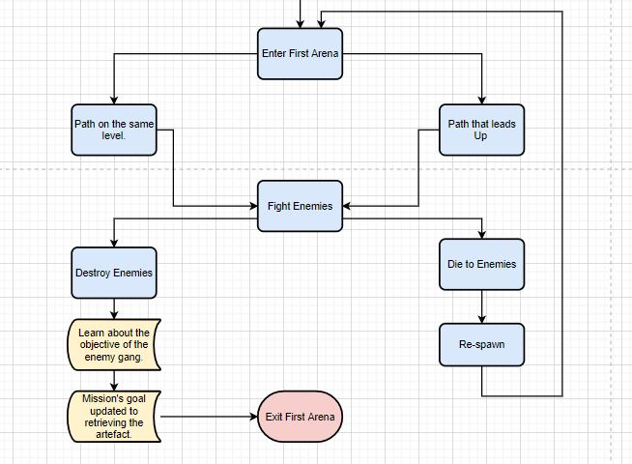
Figure 6: Forest Area

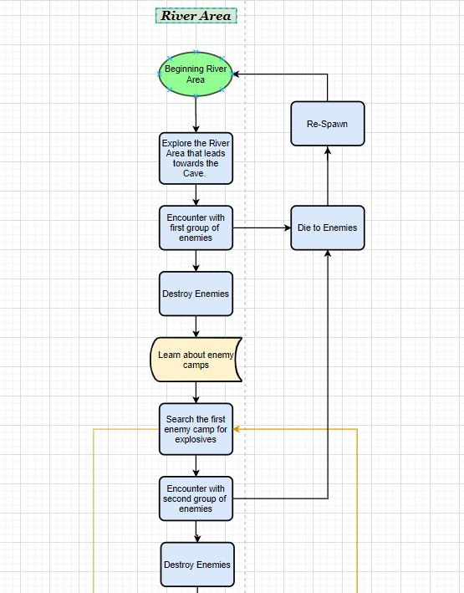

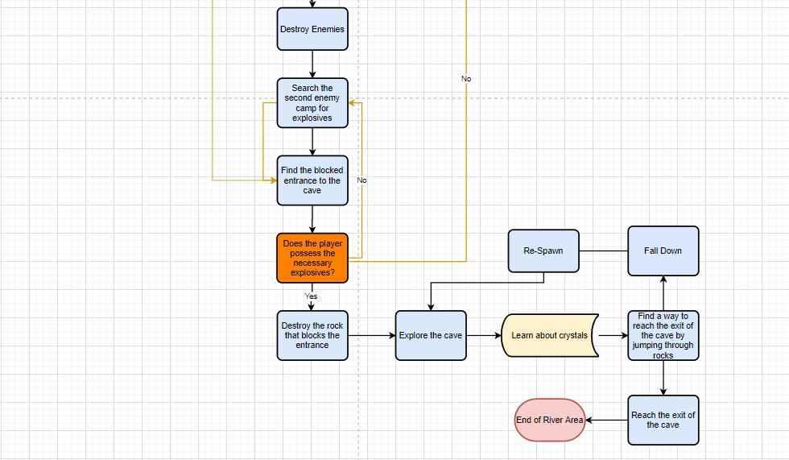
Figure 7: River Area
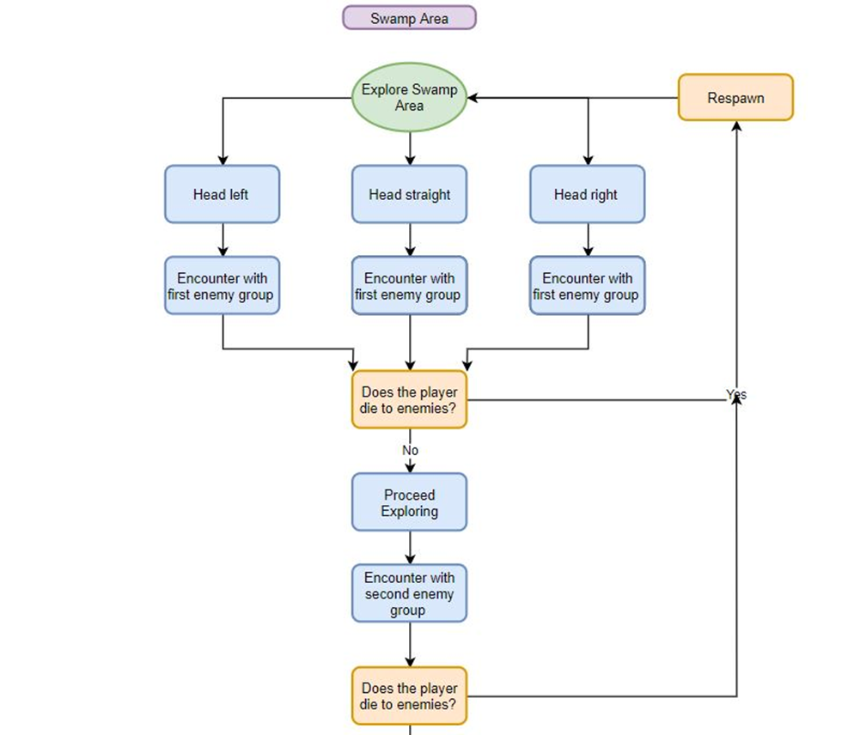
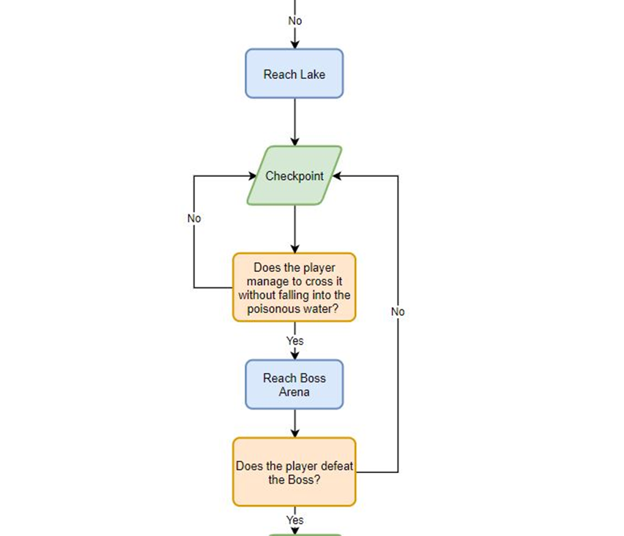
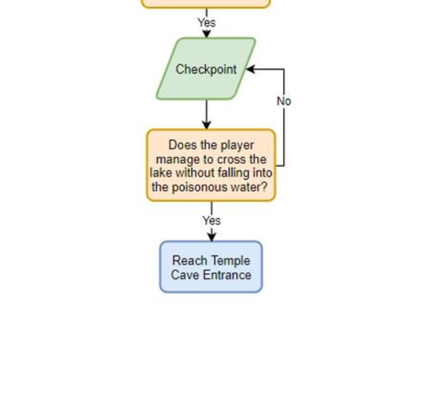
Figure 8: Swamp Area

Controls
The player will able to play around with several mechanics. The controls for each of them are:
- Walking: The player can move in space using the W, S, D, A keys. The walking speed will be set to five point five.
- Running: The player can move in space at an increased speed by pressing at least one of the walking keys plus the left shift key. The running speed will be set to nine.
- Jumping / Double Jumping: The player can jump in space using the space bar key. The jumping force will be set to fourteen. The double jumping force will be set to twenty.
- Dashing: The player can quickly cover a short distance by pressing one of the walking keys plus using the left ctrl key. The dashing force will be set to sixteen and the cooldown to one second.
- Teleporting: The player can instantly travel through space by holding the E key (a telemarker will appear showing the player its next location) and then releasing it (the player will be instantly teleported to the telemarker location). The maximum distance that the player can cover will be set to twenty and the cooldown to two seconds.
- Shooting: The player can shoot projectiles that travel through space and deal damage to enemies. The damage dealt will be set to (number placeholder), the speed will be set to thirty-five and the capacity of the magazine will be set to six.
- Reloading: The player can reload its weapon by pressing the R key. The reload time will be set to one second.

Narrative Design
Considering the game’s sci-fi theme, the level is designed to adequately showcase the story world and its surroundings. The players will occupy the planet called Thorus, which was a home for a certain ancient civilization, many years ago. The mentioned civilization disappeared for unknown reasons, but left many resources and mysteries behind them. One of these resources are so called ray crystals which are basically more powerful and efficient fuel for space travel. Erro, the playable character, is contracted there by a character named Acquisitor, whose occupation is illegal trade of rare objects and materials.
In the proof of concept, the game starts when Erro crashes into the planet’s forest area to show the character’s paradox – the space explorer whose primarily occupation is to travel through space, but he does not how to fly his own spaceship. This was also an opportunity to describe the character through humorous elements. The level is laid out in a way to give a perspective of a large and untouched planet, but to also guide the players in the right direction to their next objective. Soon after the first exploration area, the first enemy is introduced. To avoid having complicated animations, enemies are in a shape of drones, which are described as exploration machines for members of gang called Onyx Razors, with whom Erro had negative experience in the past, since they are his work competition. At the end of the proof of concept, players find out there is an ancient artifact hidden somewhere on the planet, which gives them another objective and motivation for further exploration.
Later, other parts of the level are designed to switch between exploration and combat zones to create dynamic and entertaining gameplay experience, like many other first-person shooters usually try to deliver. Erro’s final encounter is with an ancient creature, which is presented in a last “boss fight”. By defeating the giant, Erro will enter the temple where he will find the mentioned artifact and conclude his short journey.
The level often changes in environments, for instance, from the forest to the river, and from the river to the swap area. The atmospheres also vary depending on the surroundings, therefore the amount and colour of light and or fog, ground elevation, type of terrain and many other level design elements are adjusted to deliver desired player experience.

Art/Audio Direction

Art
Since the game’s genre is a first person shooter set in a fantasy science-fiction world, we chose a high-polished realistic art style to deliver a satisfying player experience. Because our players move around the world through the lenses of the first-person camera, it felt appropriate to create a detailed and complex environment for the benefit of having an immersive game atmosphere. To create a feeling of the “alien” surroundings, we took inspiration from the famous movies such as Guardians of the Galaxy, Star Wars and Avatar, and from the games like League of Legends (its set of sci-fi skins for champions like Lucian and Vayne) and Halo. To produce a convincing atmosphere, we specifically chose assets which would fit in our narrative. For example, the main pistol the players use is selected to indicate that it can fire plasma shots instead of normal bullets. Another example is protagonist’s ally named E.T.H.A.N. who is presented to the players in a form of hologram which they carry on their arm gauntlet. Additionally, all visual effects are made according to our vision of sci-fi combat and equipment. For instance, our plasma shot is inspired by the well-known Star Wars blaster pistols and our UI player health feedback consists of a field of hexagons to associate with the “space shields” known from many other media.
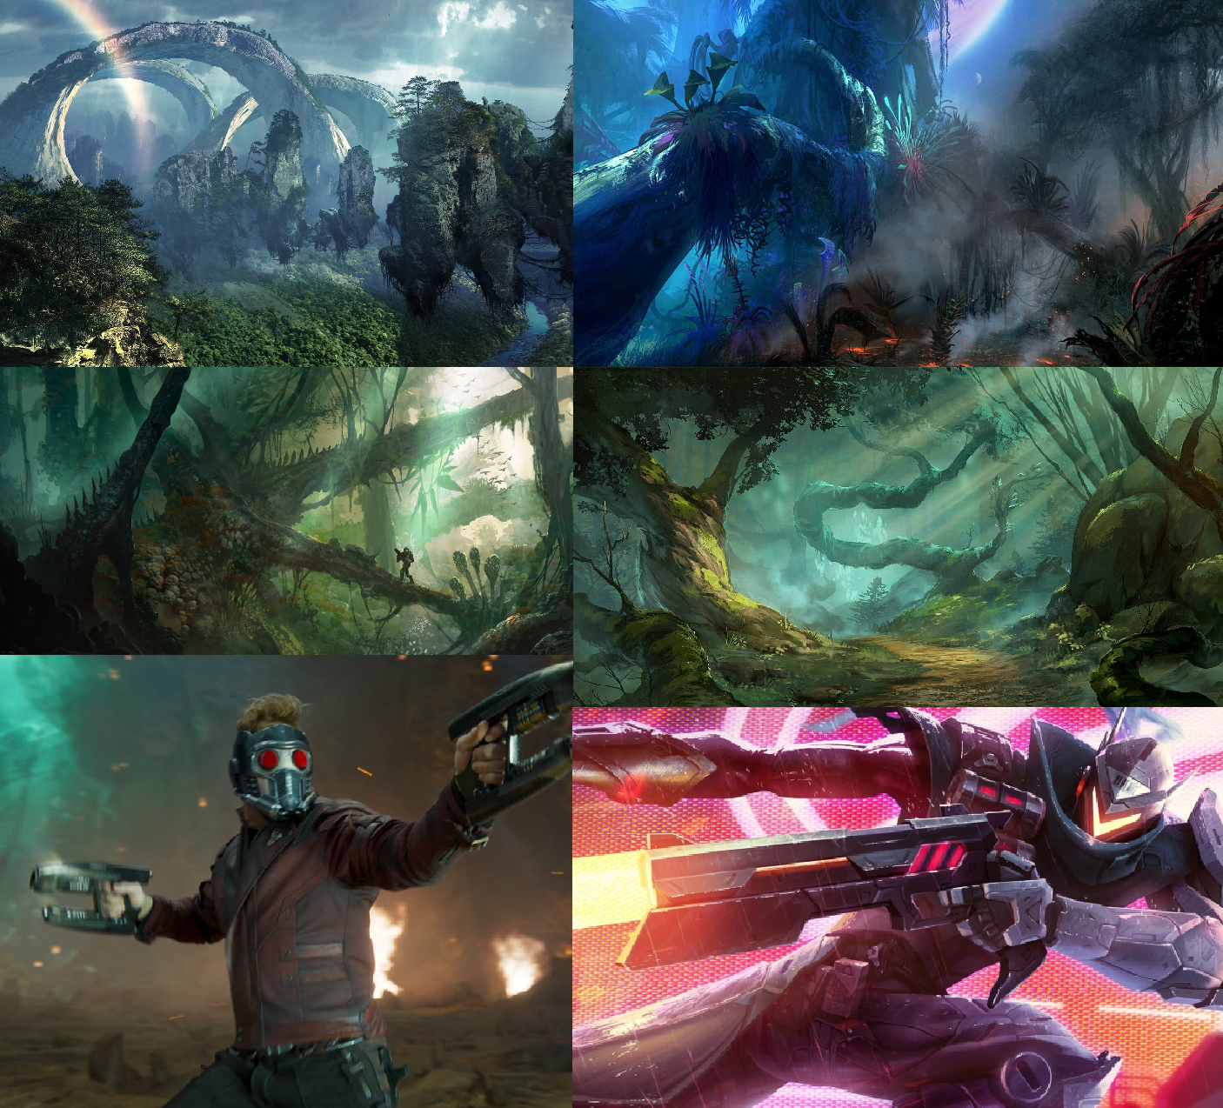
Figure 9: Mood Board

Art Style Production considerations
To achieve our desired art style, we will need to use 3DS Max and ZBrush for 3D models and Unity, GIMP and Houdini for VFX. A lot of already made assets we used (with permission) from sites like Unity Store and Sketchfab. Since the early stages of our design development, we understood that making a realistic environment would require more effort and patience to create complicated and high-quality assets. Considering that we already had the main assets sorted out, we felt capable to produce or find any other necessary assets. In the proof of concept of our level design, we will show how we designed player surroundings and how we merged together our post-processing effects and assets to create a believable and enjoyable game atmosphere.
In the alpha build, we extended our level design and therefore expanded areas players can explore. In these areas we used our naturalistic assets to deliver the desired alien atmosphere by changing the colour pallet of vegetation. Along with our new science fiction assets, we believe this change will create a better understanding of our creative direction for the players.
In the beta build, we implemented new areas which players can explore. We used different post-processing profiles, lighting, visual effects and assets to offer various atmospheres for players to experience. The issue we encountered was the lack of diverse objects we could implement in these areas because it was difficult to make or look for assets which are similar to our complex and high-quality art style. To complete our levels, we had to slightly jeopardize our creative direction and use objects we had on our disposal, which created a lot of repetition in our new areas. Our aim was to still make a stunning visual experience, so we used our level design skills as best we could to outbalance the high repetition of assets.

Audio
The overall audio style for our game is mostly instrumental music which varies depending on different scenes and moods in the gameplay. During the combat, the players will hear more tense and “epic” rhythms and while exploring they will hear slower and peaceful music. We are using voice-acting to portray our characters and give them a certain sense of their identity. The examples for our audio inspirations are Dead Space 3 and League of Legends instrumental soundtracks. We chose these music samples because we believe the music is one of the most important aspects of game design which generates the right atmosphere and emotion for player experience. By having powerful music and sound effects we want to create an immersive environment where players feel as they really taking a role of the playable character.

Audio Style Production considerations
Although our initial idea was to have an actual music composer for our in-game music, we decided to find music from online sources such as Free Sound and Sound Bible, naturally with the permission from the owners, due to the time limits and development requirements. Therefore, we will not require to have any software or hardware related to composing music. For our proof of concept, we have not focused on delivering a sample of our music preferences as we thought level design and core mechanics were far more important.
Although the main theme music for our game is yet to be implemented, the alpha build already has some sound effects which are reflecting our overall atmosphere. For example, enemy drones now have buzzing sounds when flying and rifle plasma sounds when firing. The playable character’s main weapon also has a science fiction plasma shot sound effect, although it may be changed during our later progress.
Regarding music and sound effects, we made some big changes in the beta build. For example, we implemented all voice-overs for our characters, added background music for different areas and moods, and included the majority of sound effects for every action or player behaviour which required audible feedback.

Asset List
Asset Package Name | Assets Needed/Used
SciFi Revolver: Arena (creator: aclarke064, taken from Sketchfab) | PC’s main pistol
Ely by K. Atienza (creator: K. Atienza, taken from Mixamo) | PC’s arms and hands
Artifact (creator: Neo_minigan, taken from Sketchfab) | one of the “alien” artifacts
Kultaraha, Gulden, Gold Coin KM42077:1 (creator: Museovirasto – Finnish Heritage Agency, taken from Sketchfab) | ancient coins
Magic Ring (creator: Théo Richard, taken from Sketchfab) | ancient ring
Light Cover (creator: IUPUI Center for Digital Scholarship, taken from Sketchfab) | ancient light cover
1915.338.2 Deity Earring (creator: Cleveland Museum of Art, taken from Sketchfab) | ancient earring
Lamp (creator: Världskulturmuseerna, taken from Sketchfab) | ancient candle
Lance (creator: Ruslan Malovsky, taken from Sketchfab) | ancient spear
Estela 31 de Tikal (creator: Asinoscovich, taken from Sketchfab) | ancient stone monument
Altar Ruins Free (creator: Ioan Stan, taken from Unity Store) | ancient ruins
Free SF Fighter (creator: CGPitbull, taken from Unity Store) | spaceship
Sun Temple (creator: Sandro T, taken from Unity Store) | ancient temple
Rain Maker - 2D and 3D Rain Particle System for Unity (creator: Digital Ruby (Jeff Johnson), taken from Unity Store) | rain effect
WorldSkies Free (creator: PULSAR BYTES, taken from Unity Store) | skyboxes
Post Processing Stack (creator: Unity Technologies, taken from Unity Store) | post-processing effects
Nature Assets - Foliage Package (creator: Lugia 3D, taken from Unity Store) | vegetation assets
R.A.M - River Auto Material (creator: NatureManufacture, taken from Unity Store) | river/water assets
Grass Flowers Pack Free (creator: ALP8310, taken from Unity Store) | grass assets
Rock and Boulders 2 (creator: Manufactura K4, taken from Unity Store) | rock assets
Mountain Trees - Dynamic Nature (creator: NatureManufacture, taken from Unity Store) | trees assets
NPC models (creator: Nick Golder, made in: 3DS Max) | NPC model
Pistol Plasma Bullet (creator: Jake Tidiman, made in: Unity) | VFX for PC’s bullet
UI Health Feedback Sprite (creator: Jake Tidiman, made in: Unity) | UI for PC’s health
NPC Plasma Bullet/Laser (creator: Jake Tidiman, made in: Unity) | VFX for NPC’s bullet
E.T.H.A.N.’s hologram (creator: Jake Tidiman, made in: Unity) | VFX for ally’s indicator
Teleport Aim Marker (creator: Jake Tidiman, made in: Unity) | VFX for PC’s teleport
Crystal stone (creator: GenEugene, taken from Sketchfab) | Ray crystals (pick up items)
UI Waypoint Icons (creator: Nina Alvir, made in: Adobe Photoshop) | UI navigation markers
Force Field (creator: Jake Tidiman, made in: Unity) | Sci-fi obstacles
Alien Fireflies (creator: Jake Tidiman, made in: Unity) | Alien fireflies
Alien Creature (creator: Jake Tidiman, made in: Unity) | Animated rocks and other objects
Voice-overs (creators: Nathan Fox, Jake Tidiman, Nina Alvir, recorded by: Nina Alvir) | Character voice-overs
Monster 072 by debsound (taken from: Free Sound) | Alien Creature sound effect
Sound-effects-gate-bash-in-street by soundtracvkradio (edited by: Nina Alvir, taken from: Free Sound) | Alien Creature sound effect
Giant-ice-crush-remix-of-94655 by sandyrb (taken from: Free Sound) | Alien Creature sound effect
Click-electronic-04 by littlerobotsoundfactory (taken from: Free Sound) | Button Press sound effect
Deflector-shield by metzik (taken from: Free Sound) | Space Shield sound effect
Sci-fi-force-field-impact-15 by stormwaveaudio (taken from: Free Sound) | NPC drone sound effect
Machine-drone by akx (taken from: Free Sound) | NPC drone sound effect
Motodrone by copyc4t (taken from: Free Sound) | NPC drone sound effect
Epic-orchestra-loop by joshuaempyre (taken from: Free Sound) | Battle music
Epic-tribal-drums by mattc90 (edited by: Nina Alvir, taken from: Free Sound) | Battle music
Epic-battle-music-1 by airwolf89 (edited by: Nina Alvir, taken from: Free Sound) | Intense music
Epic-heroic-orchestral-dramatic by soundflakes (taken from: Free Sound) | Closing music
Epic-finale-loop by x3nus (taken from: Free Sound) | Closing music
Epic-orchestral-cue by graham-makes (taken from: Free Sound) | Intense music
Epic-orchestra by edtijo (taken from: Free Sound) | Menu music
Classic-orchestral-for-movie-trailer-game-etc by oymaldonado (taken from: Free Sound) | Uplifting music
Saraksh by x3nus (taken from: Free Sound) | Mysterious music
Elementary-wave-12 by erokia (taken from: Free Sound) | Uplifting music
Film-for-a-music by evanjones4 (taken from: Free Sound) | Closing music
Explosion by flashtrauma (edited by: Nina Alvir, taken from: Free Sound) | NPC drone sound effect
Up5 by bumpelsnake (taken from: Free Sound) | Pick up sound effect
Laser-pulse-rifle by mohawkade (edited by: Nina Alvir, taken from: Free Sound) | NPC drone sound effect
Plasma-lazer-pistol-gun-shot-1 by erokia (taken from: Free Sound) | PC gun sound effect
Scifi-gun-plasma-hyper-lance-1 by dpren (taken from: Free Sound) | PC gun sound effect
Earthquake-1-big by ogsoundfx (edited by: Nina Alvir, taken from: Free Sound) | NPC creature sound effect
Landmass-earth-rumble by el-bee (taken from: Free Sound) | Nature sound effect
Teleport by dexus5 (taken from: Free Sound) | NPC drone sound effect
Teleport by outroelison (taken from: Free Sound) | PC teleport sound effect
Tree by 3DMaesen (taken from: Sketchfab) | Nature assets
Ghotic tree by alexmen974 (taken from: Sketchfab) | Nature assets
Grenademodel (creator: Nick Golder, made in: 3DS Max) | Grenade
Grenade VFX (creator: Jake Tidiman, made in: Unity) | Grenade VFX
Alien artifact VFX (creator: Jake Tidiman, made in: Unity) | Alien artifact VFX

Technical Considerations

Target Platform
The target platform for this project is PC using a mouse and keyboard. This is because it is the most logical release for the style of game that we are making. The target resolution will be 1920*1080 as this is the most commonly available but to allow for it to be accessible to everyone possible; the “Standalone Player” prebuilt into unity will be available to allow both, changes to the resolution and the overall quality of the game. This player choice allows us as developers to tweak the game to have the best performance for each level of detail that the player includes. As standard this will be set to a middling to high quality. This allows anyone playing to be able to play the game by not touching these settings and still having a good experience. With the PC platform, there are many methods of distributing a game. Itch.io is the standard for releasing indie titles to the marketplace while being affordable. If the opportunity presents itself, steam is a definite release option for this project. However, there is a large price barrier of entry on the store which would be a problem. An extension for the future of the game could be in the form of VR. Due to the movement system existing already in the game, it would be a relatively simple adjustment of game mechanics. But to achieve this optimisation would be key and making sure that motion sickness is a non-issue.
Alpha Update
During development up until this point, it has been clear that optimisation is going to be key on any platform or device. This challenge has proved difficult as some issues have arisen with mass disabling and enabling objects at runtime within the Unity game engine. Other considerations such as resolution have been resolved, in engine, with the “scale with screen size” on all canvas elements to allow it to be scaled correctly to each screen. Currently there is only support for standard input methods with keyboard and mouse. This combined with non re-bindable keys isn’t user friendly towards less abled players. However, that is always an option later after release if necessary.
Beta Update
In the beta the largest difference in the technical aspects of the project is the improvement in the performance. Changing the clipping distance of the camera to fit with the fog and making sure that high quality models had convex mesh colliders rather than just normal mech colliders, dramatically increased the framerate. Another change in the ability of the game is the Application Config screen presented at start-up of the game. This allows the player to choose any graphical quality and resolution that they desire. While this is depreciated and has been removed in newer versions of the Unity software, it works for now and will be implemented in the game before final release. Many attempts of building the game’s lighting have been done with one lasting over a week of compute time with it ever increasing to over 50 hours remaining, this was why other methods were looked into to increase performance within the game.

Gameplay & Systems
In this game the core gameplay is a generic first-person shooter. However, it’s the execution that is needed to make the game feel fun to play. So, the shooting mechanics is quite easy to do but difficult to master. Inspiration from other successful game is taken into consideration when creating these systems. Other systems that make this game unique, is the movement abilities of a dash and a teleport. Using both of these in collaboration, allow the player to move around the levels fluidly and in interesting ways.
By far the most intricate of these systems is the enemy AI. Each type of enemy is special, and each come with different challenges. This is the section that is most risky, needs most consideration and could affect performance if not done correctly. The complexity of this is the levels are too narrow and filled with obstacles to utilize the inbuilt AI and Nav-meshes within unity. Because of this, there are many other ways needed to be considered to find the best way of doing specific tasks. Such as creating multiple methods and testing to see what works best in given examples, trial and error. To make this even more complex, the AI is planned to be smarter than generic enemies.
Alpha Update
Many issues have arisen with regards to gameplay, but most can be solved quickly and easily. One of the key aspects of the gameplay that is taking longest is the enemy AI. One of the AI enemy has a system that includes: Multiple different attacks, Idle searching movement, Point to point movement, Group alert and is hovering all the while. This is all implemented in the game; however, it could be refined greatly. Going back to optimisation and making the game acceptable to play as a game to the end user, the optimisation methods used in the game have had some issues, specifically memory leaks. It is believed that mass disabling and enabling game objects at runtime is not really supported in the unity game engine, so more research is needed to resolve this issue before releasing the final project.
Beta Update
The AI is still the biggest issue when it comes to the gameplay but there have been many improvements when it comes to the stability and functionality of this. Due to this it was called for to separate the ai into different levels of difficulty, Low and Medium currently in the project. The low-level variety is less perceptive, slower and have less health than the medium. This change has added an increase in difficulty as the player goes through the level, in turn adding more gameplay. The new inclusion of a grenade allows the player more variety when combating the enemies.

Art & Audio
The overall look of the game is quite realistic and to achieve this may take some time. This amount of detail is going to heavily impact performance and to allow it to have the best chance of running smoothly, the code needs to be optimised. While that may not need to be the case for the first few versions, it does need to be in place for the final released project. This is to make sure that it has every possibility to run on lower end machines. Working with the Visual effects, and implementing them, is key to creating immersion into the game. But to do this, there needs to be points that allow for effects to happen. Planning and timing these events needs consideration to make sure that it fits with the event happening in the game.
Audio is one of the aspects of games that gets overlooked in creating video games, but one of the most vital. Sound increases the immersion and emotional attachment to a game. By making sure that it fits with the location and the timing is perfect, this will be a game that players remember. To achieve this, triggers and 3D sound effects placement will add weight to the game and hopefully invoke an emotional response. This is another aspect of the game that is heavily reliant on timing and planning. This planning is looking over each section of the game and working out what emotion the player should be feeling at a given point, then placing sounds and visual changes to reflect that.
Alpha Update
Most of the Art and audio aspects and responsibilities has been taken up by the designated team member. This includes things such as the optimisation technique LOD (Level of Detail) 3d models. This allows them to be used most efficiently when rendering 3d models from a distance in the game engine. All optimisation methods are being used to solve some of the issues caused by having so many game objects in the one single level. Audio is another aspect that is only now being looked into. There have been small additions to effects and general environmental aspects of the game. But now as voice acting is coming ever closer to being recorded and implemented, SFX is bringing the world alive. Actual implementation of these SFX is easy. Playing sound effects at specific times is just calling that sound effect in the code and environmental sounds are constant in their area of range. The voice acting is the tricky aspect of this. Making sure either the voice joins up mostly with the subtitles is the difficulty there. However, filling space with literal “spaces” can delay or space out words in the subtitles.
Beta Update
The main addition in the beta of art and audio is the audio side of it. This includes voice lines, AI/Player sounds, environmental sound effects and music. Triggering voice lines and timing everything to make it fit together, is something that will be needed to be tweaked to make it more accurate before the final release. But it is fully functional and close enough for now. In the beta there are triggers that change the music dependent on what stage the player is at. This allows it to be changed to best fit the situation that is being presented to the player. This works well with the new addition of the Swamp level and boss, as this changes the tone of the game. There are many different considerations when implementing the visual side of the swamp. Getting the feel of the swamp right while making sure that it’s still properly optimised was a challenge especially when it comes to getting the lighting right.

Project Structure & Naming Conventions
Within this project every person in the project has their own folder. This is to restrict conflictions when using version control applications, in this case GitHub. But due to the large file size of the assets in the game, an offshoot called LFS, Large File Storage, is needed to be able to use the project due to the limited storage in a standard GitHub repository.
Everything in the project will have an appropriate name corresponding to the nature of that object. Because the game is a collaboration, personally naming every object and asset after the person creating it could lead to problems with ownership. So, to avoid this issue, everything is named by purpose within their folder for cleanliness and ease of access. Code on the other hand, does follow the standard coding conventions of naming conventions especially of variables and methods. This is because it is expected and makes it easier to read for any other person looking at the code other than the original writer. Commenting and creating regions is also another cleanliness and mindfulness addition to the code that allows it to be more accessible to other members of the team.
Alpha Update
Keeping everything updated through GitHub and OneDrive is already established from the initial setup and is in constant use. Due to everyone having separated folders, combining prefabs and other key parts of the game, is the person responsibility of that person to implement it into the combined game project. There have been very few issues with combining the projects after the first few initial setup issues. Things such as overwriting prefabs, not actually overwriting them in the game scene has been a small annoyance, but only a small issue in the grand scheme of things.
Beta Update
GitHub is getting used as the testing and demo location for scripts and assets for the combined project. While only one person has been working with the combined project, due to the current global pandemic and social distancing measures, it has been issue-free when combining assets with the project due to careful checks for any overwriting when merging. All other naming and commenting conventions have been upheld.

Production Schedule
Risks
One of the key risks to the production of our game is the failure to combine code with assets smoothly. There are two ways we can combat this; the first is by using GitHub, the version control software safeguards our previous work and lets us backtrack if needed. The second is giving ourselves enough allocated time in the production plan to allow for any problems a merge could arise. We have discovered a terrible frames per second issue due to the high-quality assets we are using, if we cannot combat this it will drastically reduce the quality of our game.

Key
Producer | Design Lead | QA Lead | Tech Lead | Art/Audio Lead

Alpha
Task Name | Week Number  Dec 30th | Week Number  Jan 6th | Week Number  Jan 13th | Week Number  Jan 20th | Week Number  Jan 27th | Week Number  Feb 3rd | Week Number  Feb 10th | Week Number  Feb 17th | Week Number Feb 24th
Merge the two proof of concepts
Create second enemy type
Work on NPC AI
Merge code with polished level
Test merged concepts
Make NPC models
Test grey boxed level
Create ‘alien’ structures
Test Combat zones
Test gameplay in the entire level
Design Second enemy type
Grey box the rest of the map
Add assets and detail
Design combat encounters
Design/ create player UI objects
Create drone death animation
Create second enemy attack effects
Improve companion effects
Add UI for interactable objects
Conduct progress meetings
Create or find ambient sounds for each area of the level
Finalise NPC and PC sound effects
Design narrative plot points for the rest of the level
Begin designing title page art

Beta
Task Name | Week Number  Feb 24th | Week Number  March 2nd | Week Number  March 9th | Week Number  March 16th | Week Number  March 23rd | Week Number  March 30th | Week Number  April 6th
Create Boss NPC AI
Merge code/VFX/Models with level
Finalise UI
Finalise NPC effects
Create Boss effects
Conduct progress meetings
Design ‘alien’ artefacts
Create end Scene
Create title screen
Create intro scene
Implement combat zones
Implement narrative
Create boss arena
Model boss NPC
Model alien artefacts
Test boss NPC gameplay
Test completed beta

Final
Task Name | Week Number  April 7th | Week Number  April 14th | Week Number  April 21st | Week Number  April 28th | Week Number  May 4th
Fix bugs

Improve code performance
Polish visual effects
Improve VFX performance
Polish level

Improve Performance
Test game

Revise and polish title screen / audio

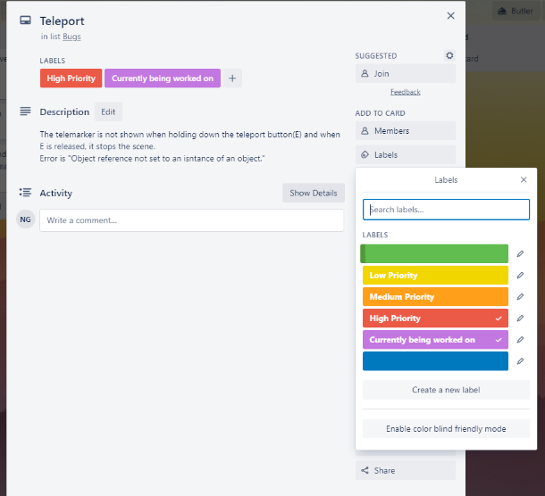
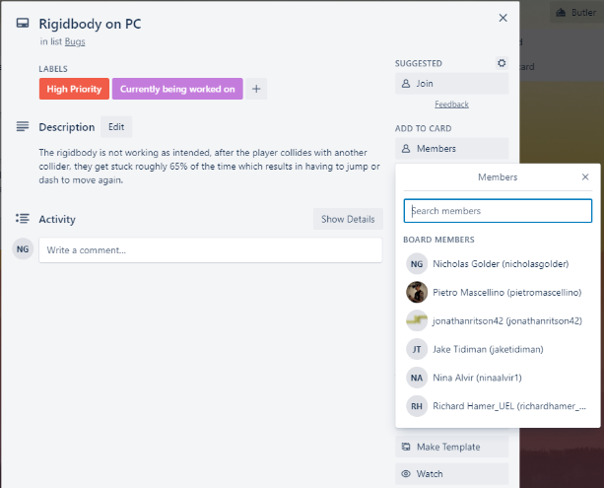
Overall Test Strategy
We decided that just like the rest of our Trello board, we will have a bugs section as well as a bugs fixed section, via this layout we will be able to list all of the current bugs that have been found within the current build as well as drag them over to the completed list once they have been resolved. As shown by the screenshot on the right, Trello allows us to assign members to a specific card, not only can everyone see what members have been assigned to, but the person who was assigned also gets an email notifying them that they were assigned a task. The bug reports will be written down within a word document template which will have sections that can be filled in, for example, Summary of problem, the actual result, the expected result, how to replicate the issue and the Severity. Trello has a feature called labels which by using we can name and set labels on cards so that they can be labelled as low, medium or high priority as well as whether work has begun on the bug. The highest priority when working on bugs is obviously the ones which break the game for example the Rigidbody bug in the second screenshot on the right which causes the player to get stuck 65% of the time in other objects colliders. This was partially mentioned in the first paragraph of the Overall Test Strategy section however to reiterate, open bugs will be in the bugs section on Trello as well as labelled with their priority, when work begins on that bug their state will change to “currently being worked on” which is shown via the label. A bug fix has been tested and confirmed to work, it is then moved to the "Bugs, Fixed" section.

Feature Test Plan
Feature Name | Player Movement
Test Objective | Player can move in the direction that was pressed e.g. A for left, D for right, W for forward
Steps | - Run any scene featuring the PC  - Make sure the keyboard is plugged in properly to the pc  - Press any of the movement keys (W,A,S,D)
Expected Result | The player will move in the indicated direction and not pass through objects in the scene.
Actual Result | TO BE FILLED IN
Pass/Fail | TO BE FILLED IN

Feature Name | Teleport System
Test Objective | Player is teleported to the marker that was pointed at the chosen teleport area.
Steps | - Run any scene which features the PC  - Hold down E  - Point the mouse where the player wishes to be teleported  - Let go of the E button
Expected Result | The player will be teleported to the chosen point
Actual Result | TO BE FILLED IN
Pass/Fail | TO BE FILLED IN

Feature Name | Gun shooting and reloading
Test Objective | Player can fire the gun upon pressing the fire button and reload when out of ammo
Steps | - Run any scene which features the PC  - Press the left mouse button  - When ammo is empty, press the R key on the keyboard.
Expected Result | The player will be able to fire the gun
Actual Result | TO BE FILLED IN
Pass/Fail | TO BE FILLED IN

Feature Name | Change weapon
Test Objective | Player can switch their weapon upon pressing the key
Steps | - Run any scene which features the PC  - Press 2 on the keyboard
Expected Result | The player will switch to a different weapon
Actual Result | TO BE FILLED IN
Pass/Fail | TO BE FILLED IN

Feature Name | NPC enemy notices the player
Test Objective | When the player walks in front on the NPC, it should lock on and attack
Steps | - Run any scene which features the PC and NPC  - Walk in front of the NPC
Expected Result | The player will be attacked by the NPC
Actual Result | TO BE FILLED IN
Pass/Fail | TO BE FILLED IN

Feature Name | NPC different attacks
Test Objective | When the NPC gets to low health, the attack will change from bullet to a charged-up laser
Steps | - Run any scene which features the PC and NPC  - Walk in front of the NPC and shoot at it  - After 2 to 3 hits the NPC should switch attack to the laser
Expected Result | The NPC will charge up its laser when it reaches low health
Actual Result | TO BE FILLED IN
Pass/Fail | TO BE FILLED IN

Feature Name | Waypoint system
Test Objective | There is a waypoint in the level pointing to where the player should go, when the player gets near it, the marker should then move to the next section.
Steps | - Run the game and walk towards the first waypoint
Expected Result | The waypoint will then move to the next location related to the story.
Actual Result | TO BE FILLED IN
Pass/Fail | TO BE FILLED IN

Bug Report Workflow
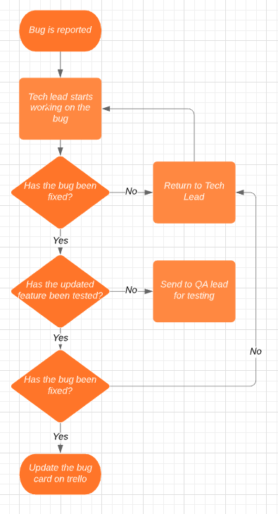
As spoken about in the Overall Test Strategy section, the bugs reported in the game go through four different stages, firstly being reported, next is the bug being worked on by the Tech Lead, up next is a fix for that bug being sent to the QA Lead to test it and if the test was a success and the bug is confirmed fixed then the bug moves to the completed stage. As shown via the flowchart screenshot on the right, after a bug is reported, it is sent to the Tech Lead who will start working on that bug. After the Tech Lead has finished a fix/ potential fix, it is then sent to the QA Lead who will then test the updated feature that previously had the bug, if the bug fix did not work as intended then it is sent back to the Tech Lead with the details of what happened during testing. If the bug fix that the QA Lead tested did work, then the card relating to that bug is updated on the Trello board and moved to “Bugs, Fixed.”

Meeting Notes
Alpha Meeting Notes
07/07/2020
- Level design is coming along well – needs to look more alien
- NPC explosion looks good – needs a camera shake effect
- Ammo counter created – needs to be merged with the gun code
- Script is still in development
- Second NPC model needs to be researched and modelling needs to be created

20/01/2020
- Jake – create effects for ground NPC, fix colour variation in the laser beam effect
- Nick – create more flying structures, destroyed NPCs for the explosion effects, second NPC
- Nina – condense dialogue, start temple area, start title page
- Pietro – start cave and swamp area
- Jon – fix AI bugs, start second NPC, create interaction script

27/01/2020
- Continue changing colours of environment assets
- Create alien assets – mushrooms, plants etc
- Work on contrasting the colour of NPC and environment so they stand out more
- Finalise interaction script
- Design and implement narrative environment sections

3/02/2020
- Create attack effects for ground NPC, fix material exporting issues
- Test ground NPC code and model in the scene
- Get feedback on temple area – maybe change the design
- Start work on NPC scan effect
- Finalise ground NPC AI

13/02/2020
- Revise all our play testing notes and our testing notes
- Screen sometimes gets stuck being very blurry
- Enable/disable environment script sometimes doesn’t work
- NPCs disappear when directly above the PC
- Reload should be quicker
- We need to add a tutorial segment at the start of the level

24/02/2020
- Tutorial section isn’t clear enough where to go
- Teleport sometimes glitches the PC through colliders
- Completed a lot of user testing, will review in next meeting

Beta Meeting Notes
04/05/2020
We discussed everyone’s progress from the previous two weeks, Jon provided a detailed account of his work to counter the various bugs we had found during the previous testing and gave us a deadline for our assets so he would have enough time to implement them all for the beta admission. Nina discussed user interface design and added to the VFX assets list. Pietro discussed his progress with the level as well as overall design decisions about environment density and look. Nick discussed his progress with texturing the various models he has created for the project as well as the possibility of re-factoring his models to work with a vertex shader. Jake discussed his progress with grenade VFX and gave an estimate for the completion of the new VFX assets added to the list.
27/04/2020
Jon had completed a new beta build for testing, so we all thoroughly tested it and provided feedback on bugs and revised previous design decisions. We also discussed our individual progression and gave feedback on others work.
23/04/2020
We discussed the design and implementation of a grenade for the player character and delegated the work to complete it accordingly. We discussed all our contributions over the past few weeks and decided we had all not allocated enough of time to this project, so we then adjusted our schedules to ensure we would make the beta hand in in a way we were happy with. We also discussed re-inventing ETHANS watch as now it didn’t fit well with the effect it produced. Nina and Pietro will work on polishing the final section of the game and Jon will work towards fixing as much bugs as possible and make a new build for us to test.
15/04/2020
We discussed the overall boss design and the work needed to complete it for the deadline, deciding to cut the amount of attacks it had for the beta hand in from 4 to 3. We also discussed changing ETHANS effect so to be more easily recognisable as something which is talking to the player. We also discussed our playtests of the current beta build - possible bug fixes and design decisions.
09/04/2020
We mostly discussed the light baking progress which Jon had spent the last few days completing, we decided that as it still hadn’t completed and was seemingly frozen to stop trying to bake the lights and look for other ways to improve the performance of the game.
06/04/2020
We discussed the new deadline for the beta admission and how this would affect our progress and individual timelines. We proposed a new timetable for ourselves and re-factored the importance of certain features given the extra time. Nina and Jake organized a meeting to record dialogue, Nick worked on textures for the boss model, Pietro discussed his progress on the swamp section of the level and how the limited set of assets meant that our intended look may have to be compromised. Jon discussed the light baking progress and his own work on bug fixing.

Playtests
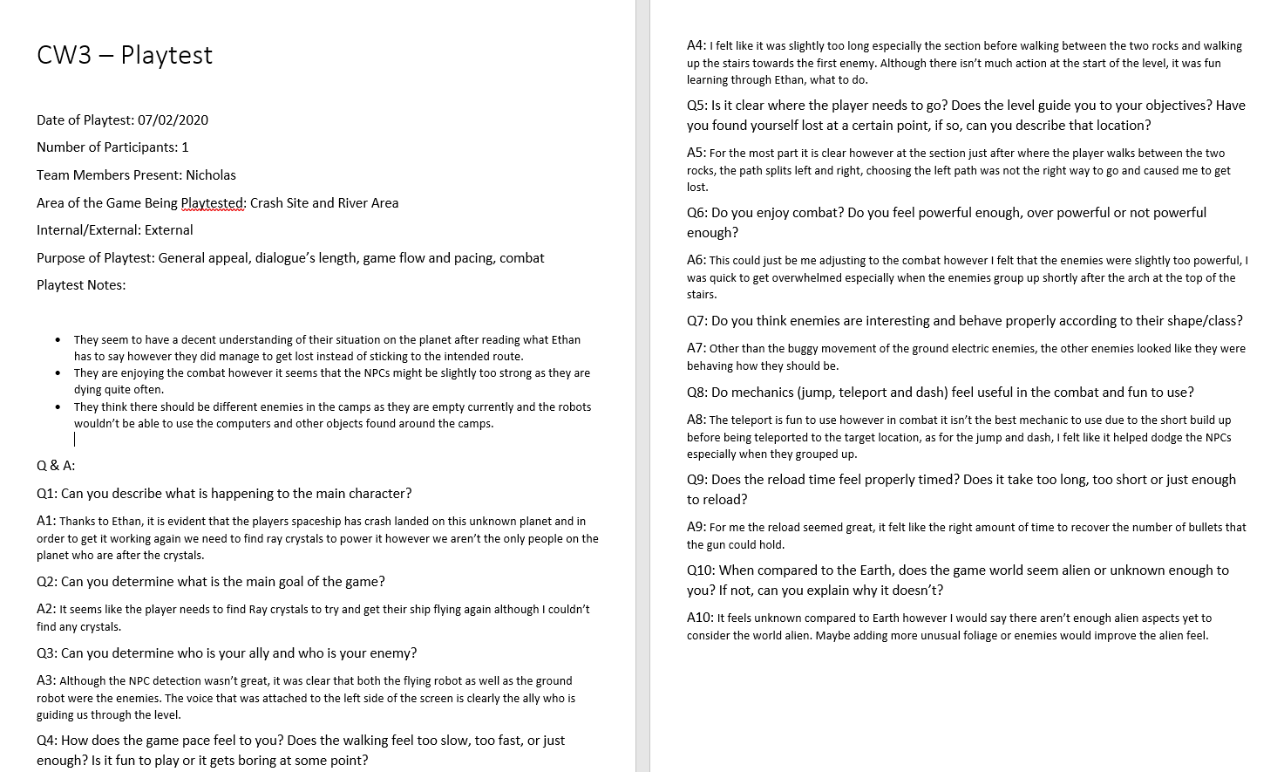
Figure 15: Playtest 1 (07/02/2020)

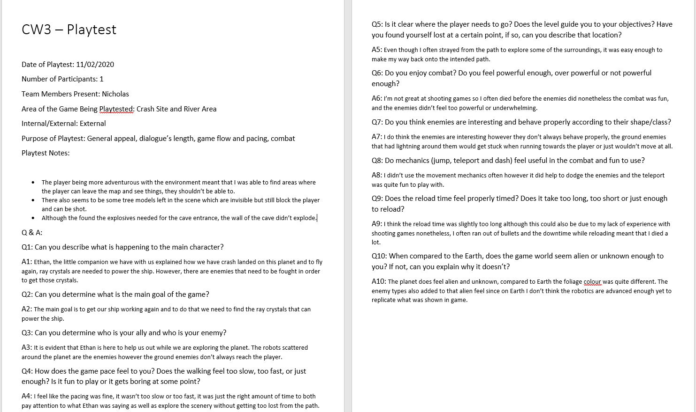
Figure 16: Playtest 2 (11/02/2020)

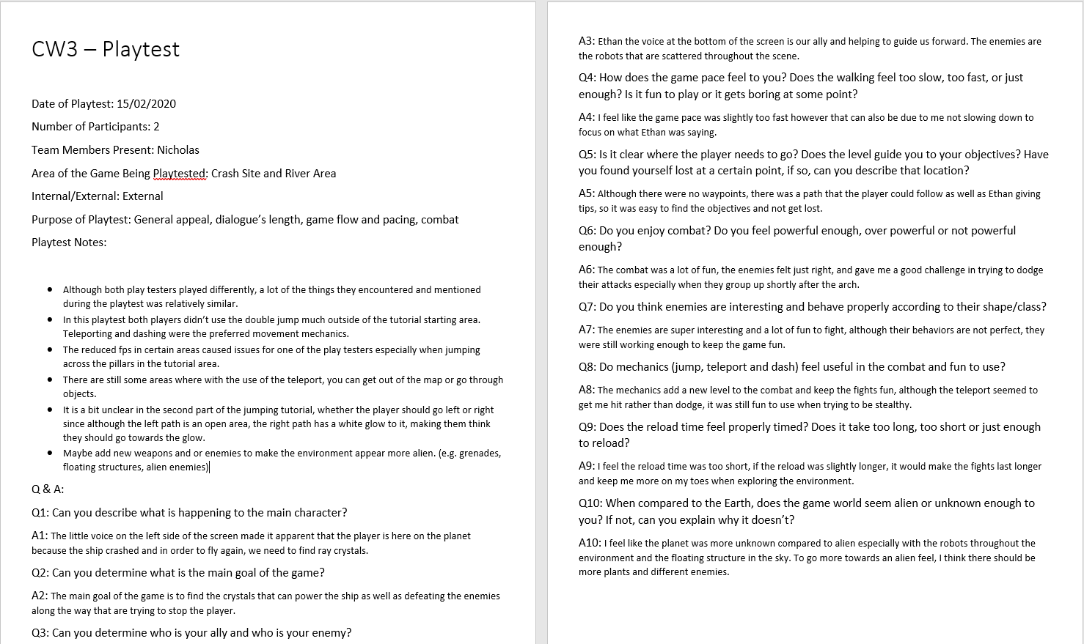
Figure 17: Playtest 3 (15/02/2020)

Reflection on playtesters’ feedback (alpha build)
A common answer for the comparison of Earth to our alien/ unknown planet is that while it does show that it is alien and unknown, there should be more elements of alien on the planet for example, glowing plants, more structures floating in the sky, more varieties of enemies, instead of robots have more alien/humanoid enemies. To combat this some models have been made for example mushrooms as well as another floating structure, to make them ready for the game, textures need to be applied. As for enemies, that is still to be decided. As mentioned in the previous sentence, it was agreed that the QA lead would make some mushroom models as well as another floating structure, it is then up to both the level design and QA lead to textured those assets so that they are ready to be placed in the environment.
Another big thing for the game is the optimization, during the playtests, some areas were as low as 10fps while others were closer to 60. Although the testers were fine with the lower framerate, to make the game more enjoyable we need to try to better optimize the game via downgrading textures or removing/ adding back in models on triggers. The lower framerate is believed to be due to the large amount of game objects within the game as well as the quality of some of the textures e.g. rocks and flowers. There are three fixes the tech lead has in mind to help combat the framerate issue, with the first potential fix being OnBecomeInvisible, however it has not helped with performance. Secondly, SphereCast around the player so anything that went in the sphere was loaded however due to the number of objects being loaded, it was too demanding on the pc so that option wasn’t viable. Thirdly is Unity’s occlusion culling, which renders all the possible viewing angles to notice what is being shown in the camera at any one time and then not rendering anything outside of that view. The third option is still being tested however if that does not work either then a new potential fix will need to be discussed in the next team meeting.

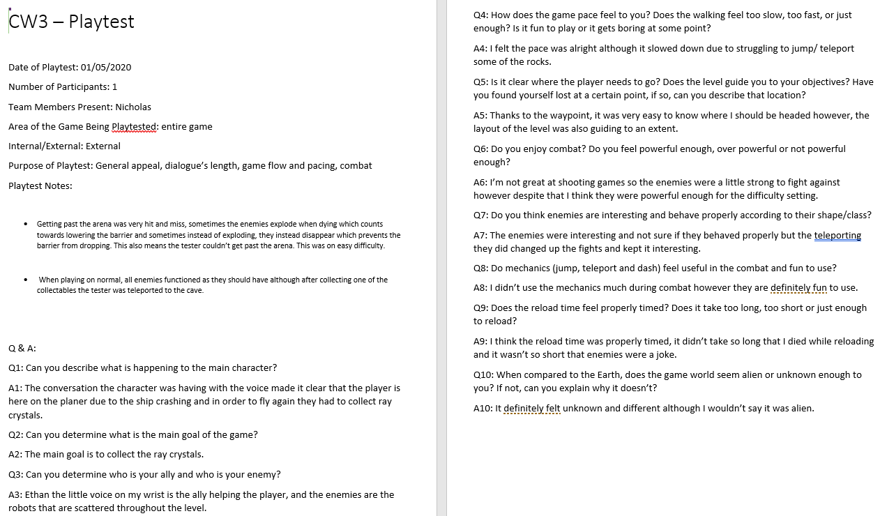
Figure 10: Playtest 4 (01/05/2020)

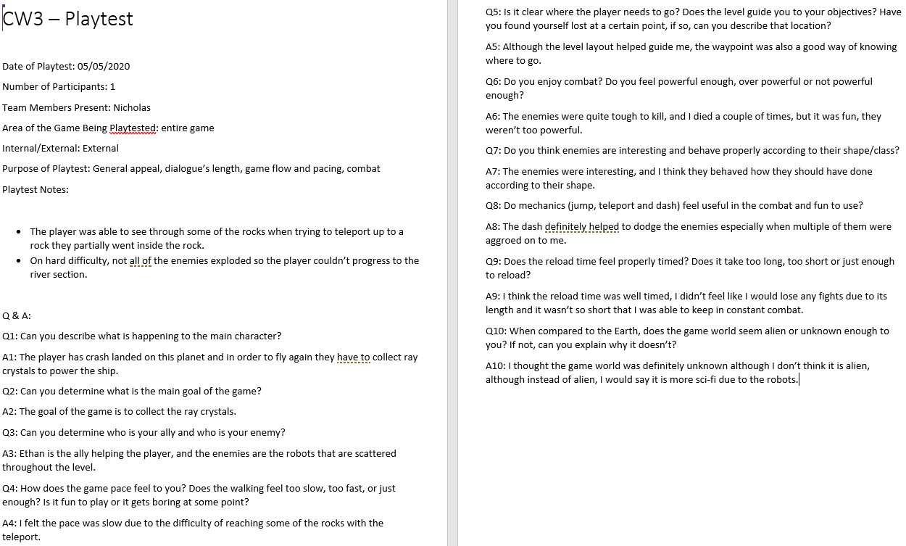
Figure 11: Playtest 5 (05/05/2020)

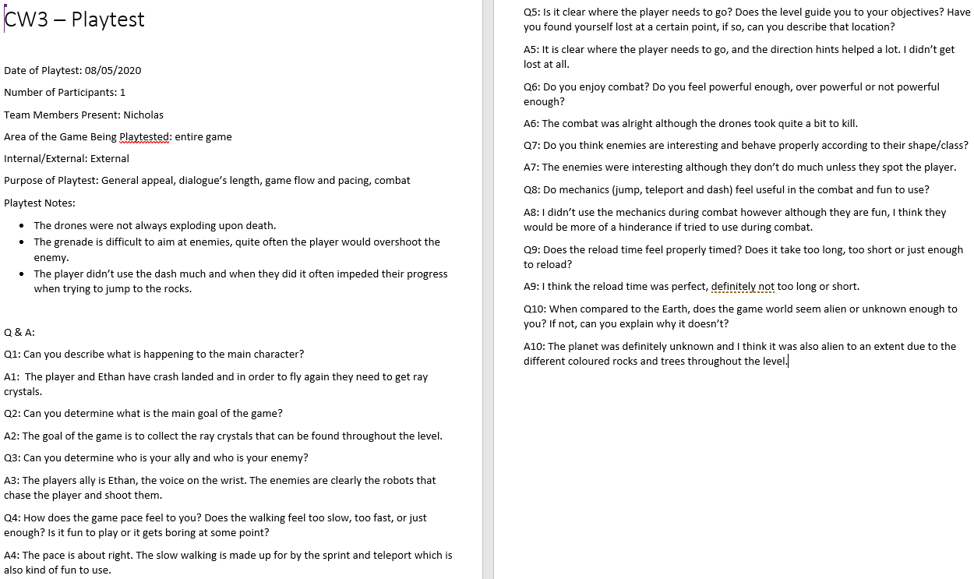
Figure 12: Playtest 5 (08/05/2020)

Reflection on the playtesters’ feedback (beta build)
The game was enjoyable, and the testers had fun however the arena was a common issue for all of them. The results varied depending on the difficulty however nonetheless the issue was that enemies didn’t always die so the barrier wasn’t being triggered after all of them disappeared. To combat this, we would need to look into the hit detection of the enemies and what is happening to them throughout a fight scenario, this would be primarily done by the technical lead. Another big issue is both the cave area and optimisation, when that area was reached, if the player fell off of one of the floating rocks or one of the pillars then they couldn’t find a way to get back up to the top of those pillars so were stuck there. Furthermore, framerate seemed to drop during this section which increased the difficulty of the section. To rectify this, we would need to look at the colliders of the rocks to make sure there is a pathway to get back up to the top of the rock formations so that if players do fall then they can still get back up. This would be done by the design lead. To try to optimise that section so framerate is better, the technical lead can use Unity’s occlusion culling, which renders all the possible viewing angles to notice what is being shown in the camera at any one time and then not rendering anything outside of that view. However, if that does not work then a new potential fix will need to be discussed in the next team meeting.

